E.G.S PILLAY ENGINEERING COLLEGE-NAGAPATTINAM

DEPARTMENT OF CIVIL ENGINEERING
CONTENT BEYOND SYLLABUS

STAFF NAME: Mr. M.ANBARASAN.,A.P/CIVIL BATCH: 2014-2018
YEAR/SEM: III//V SECTION: A & B
SUB NAME & CODE: FOUNDATION ENGINEERING & CE 6502

FOUNDATIONS FOR INDUSTRIAL MACHINES ANDEARTHQUAKE EFFECTS

Machine foundations are special types of foundations required for machines, machine tools and heavy equipment’s which have wide range of speeds, loads and operating conditions. These foundations are designed considering the shocks and vibrations (dynamic forces) resulting from operation of machines.
Following are the types of machine foundations generally used:
1. Block Type Machine Foundation:
Following figure shows block type machine foundation. This type of foundation consists of a pedestal resting on a footing have has large mass and a small natural frequency.
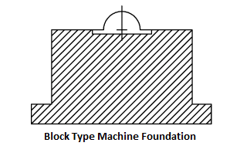

2. Box or Caisson Type Machine Foundation:
Box type foundation consists of a hollow concrete block as shown in figure below. The mass of this foundation is less than block type machine foundation as it is hollow. The natural frequency of the box type machine foundation is increased.

3. Wall Type Machine Foundation:
This type of machine foundation consists of a pair of walls with a slab resting on top. This type of foundation is constructed of homogeneous materials. It is used for small machines and the machine is rested on the top slab.

4. Framed Type Machine Foundation:
This type of machine foundation consists of vertical columns with horizontal frame at their tops. It is used for larger machines. The machines are rested on the top of frames. The vertical and horizontal members of this foundation can be constructed by different materials.

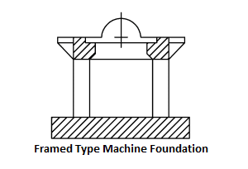
5. Non-Rigid or Flexible type of Machine Foundation
Following figure shows the non-rigid or flexible foundation.

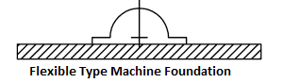

The following general requirements of machine foundations shall be satisfied and results checked prior to detailing the foundations.
1. The foundation should be able to carry the superimposed loads without causing shear or crushing failure.
2. The settlements should be within the permissible limits.
3. The combined centre of gravity of machine and foundation should, as far as possible, be in the same vertical line as the centre of gravity of the base plane.
4. No resonance should occur; hence the natural frequency of the foundation–soil system should be either too large or too small compared to the operating frequency of the machine. For low-speed machines, the natural frequency should be high.
5. The amplitudes under service conditions should be within permissible limits which are prescribed by the machine manufacturers.
6. All rotating and reciprocating parts of a machine should be so well balanced as to minimize the unbalanced forces or moments.
7. Where possible, the foundation should be planned in such a manner as to permit a subsequent alteration of natural frequency by changing base area or mass of the foundation as may subsequently be required.
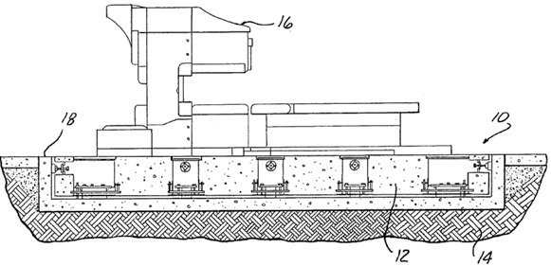

Fig: Machine Foundation
From the practical point of view, the following requirements should be fulfilled.
1. The groundwater table should be as low as possible and groundwater level deeper by at least one-fourth of the width of foundation below the base plane. This limits the vibration propagation, groundwater being a good conductor of vibration waves.
2. Machine foundations should be separated from adjacent building components by means of expansion joints.
3. Any steam or hot air pipes, embedded in the foundation must be properly isolated.
4. The foundation must be protected from machine oil by means of acid-resisting coating or suitable chemical treatment.
5. Machine foundations should be taken to a level lower than the level of the foundations of adjoining buildings
Machine Foundation is subjected to dynamic loads. These loads develop the vibratory motions which will transmit into the soil below the foundation. The effect on soil caused by these vibrations is analyzed using principles of soil dynamics and theory of vibrations.

Types of Vibrations in Machine Foundation
There are two types of vibrations in machine foundation:
- Free vibration
- Forced vibration
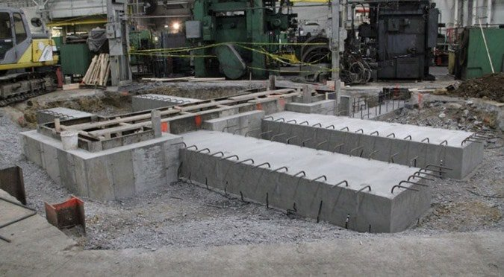

FREE VIBRATION IN MACHINE FOUNDATION
Free vibrations occur without any external force and they occur under the influence of forces in the system itself. But to start free vibrations, initially an external force or natural disturbance is required. Free vibrations may be of two types as follows
- Damped vibrations
- Undamped vibrations

Forced Vibration in Machine Foundation
Forced vibrations occur with continuous external forces on machine foundation. Let us say a damped system is subjected to exciting force F(t). The equation of motion can be written as
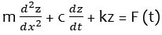

Vibration Analysis of Machine Foundation
To analyze the vibration theory of machine foundation we need to assume that the machine foundation has single degree of freedom. Normally machine foundation has 6 degree of freedom.
Let us say a machine foundation is rest on soil mass. Now the mass of machine and foundation acts downwards together and it is say m_{f} which acts at the center of gravity of the system. The mass of soil which acts upwards is say m_{s.} the elastic action of soil due to vibration of system is dependent of stiffness k. Resistance against motion is dependent of damping coefficient c.
So, these three mass, stiffness and damping coefficient are required to complete the analysis of machine foundation. Determination of above parameters is explained below.

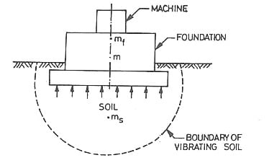

Mass (m)
Whenever the machine vibrates, soil below the machine foundation also vibrates. The mass of soil which vibrates due to machine vibration is termed as in-phase soil mass. Therefore, total mass (m) is equal to
m = m_{f} + m_{s}
Where,
m_{f} = mass of the foundation
m_{s} = in-phase soil mass = it varies from 0 to m_{f}
Total mass (m) varies from m_{f} to 2m_{f.}

Stiffness (k)
The stiffness is dependent of type of soil below the foundation, embedment of foundation block and contact pressure distribution between soil and foundation. Stiffness is derived from the following methods.

Laboratory Method of Vibration Analysis
In the laboratory, a tri axial test with vertical vibrations is performed and modulus of rigidity is obtained. From this young’s modulus is determined with the help of Poisson’s ratio.
Young’s modulus E = 2G(1+u)
Stiffness k = AE/L
Where E = young’s modulus
G = rigidity modulus
U = positions ratio

Barkan’s Method
The stiffness can also be derived from the formula proposed by Barkan which is given below.
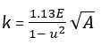
Where A = area of contact

Plate Load Test
A plate load test is conducted in the field and determines the stiffness of soil as slope of the load-deformation curve.
For cohesive soils, Stiffness K
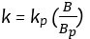
For cohesionless soils, Stiffness k
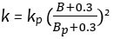
Where,
B = width of foundation
B_{p} = diameter of plate

Resonance Test
By knowing the resonance frequency (f_{n}), we can calculate the stiffness value. f_{n} can be determined by placing vibrator of mass m on a steel plate supported on ground.
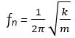
Therefore, stiffness

Damping Constant (c)
When the vibration energy dissipates from the soil, damping occurs. The main reasons to develop damping is internal friction loss due to viscous effects and hysteresis, radiational losses due to propagation of waves through soil.
The damping constant c is obtained from the area of hysteresis loop of load deformation curve as follows
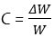
Where,
= work lost in hysteresis
W = total work done.
The damping constant varies from 0.01 to 0.1

